# **Blood Bank Management System**

DATABASE MANAGEMENT SYSTEM CS-306

# 

Group ID: 28

Sana ullah CS-17144/17

Muhammad Shoaib CS-18301/18

Rahul Roshan CS-17302/17

Department of Computer System Engineering

NED University of Engineering & Technology karachi, Sindh Pakistan

# Updated Schema:

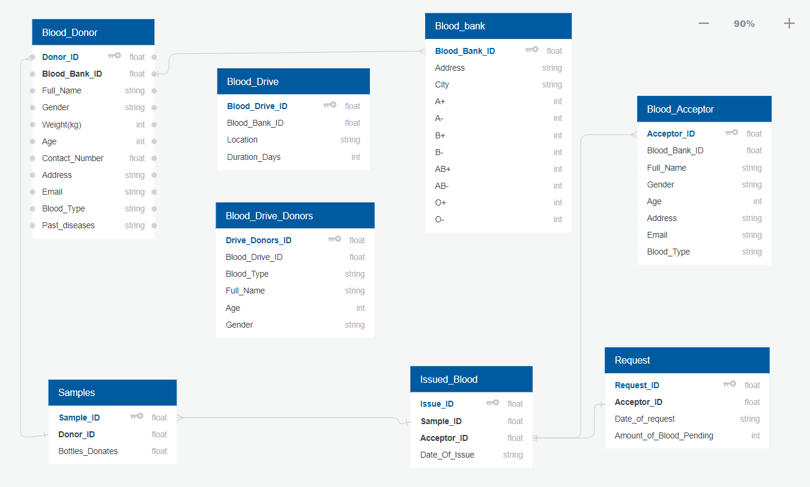

Schema after normalization on next page:

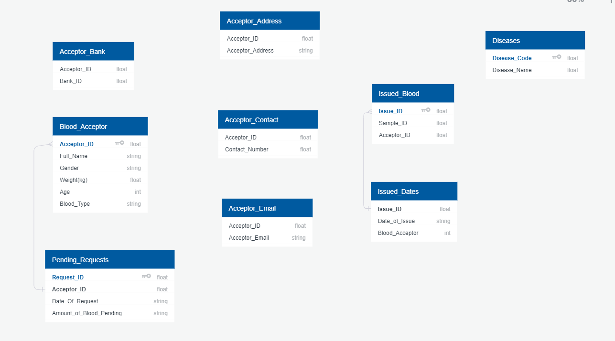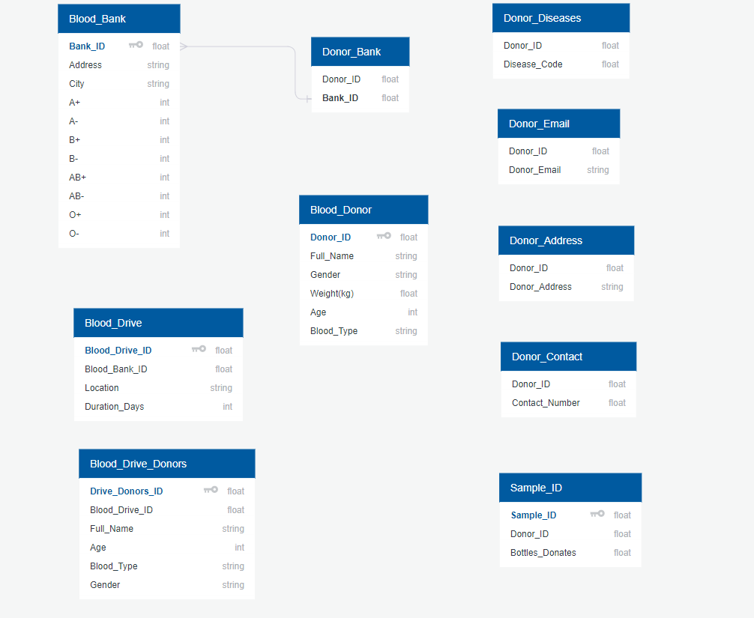

# Updated EER Diagram:

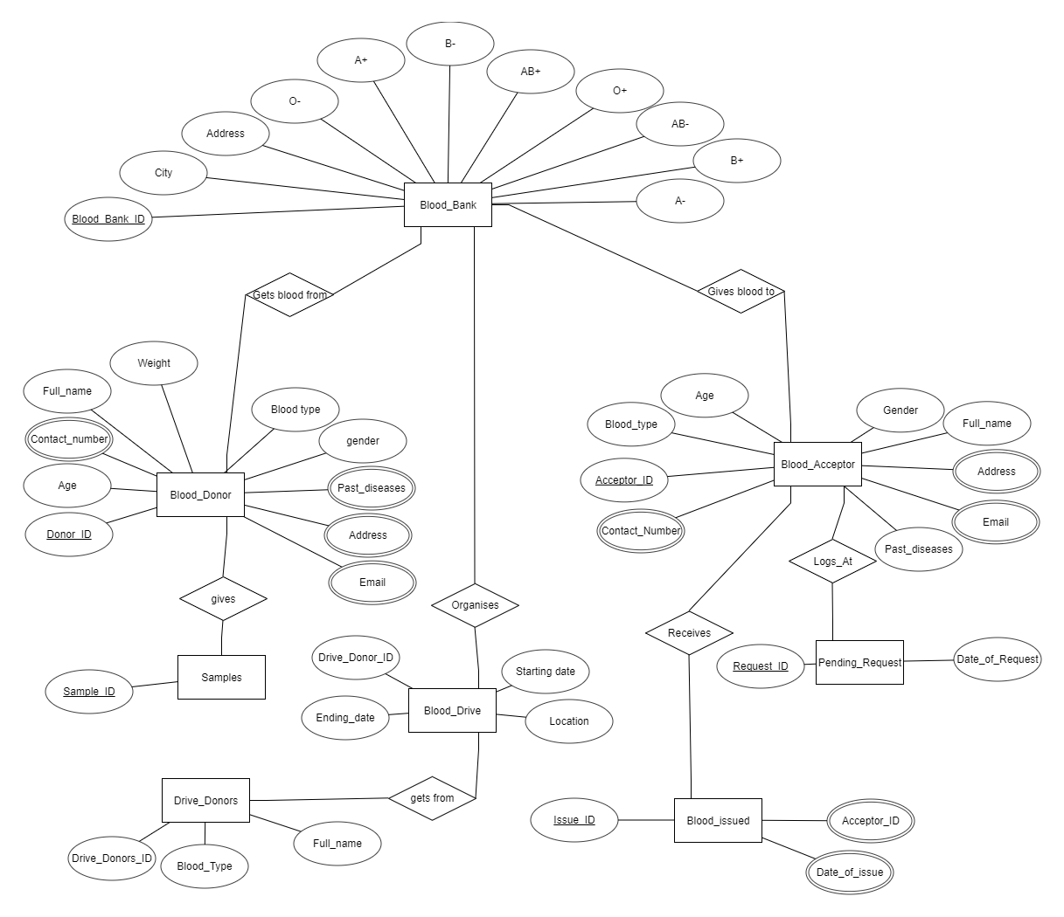

**Queries**

Query 1

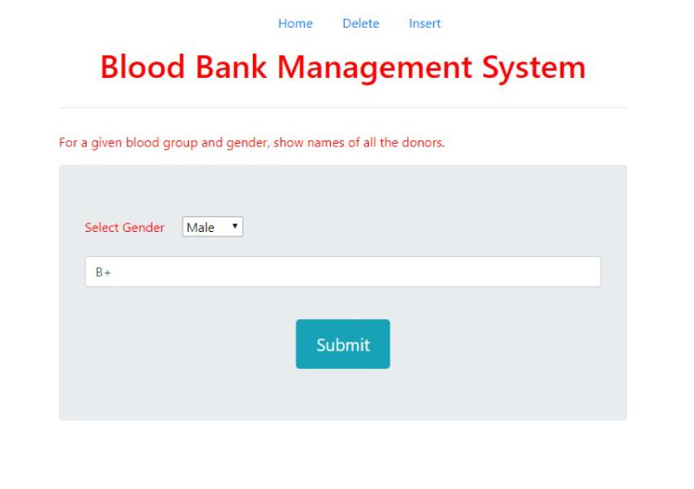

Result:

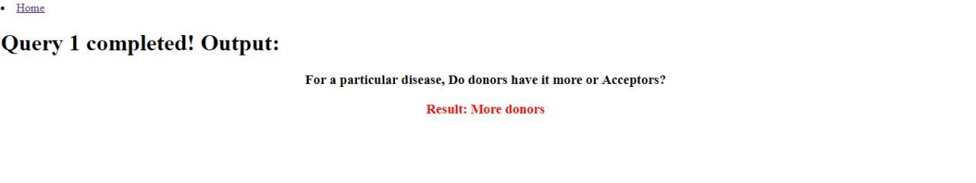

Query 2:

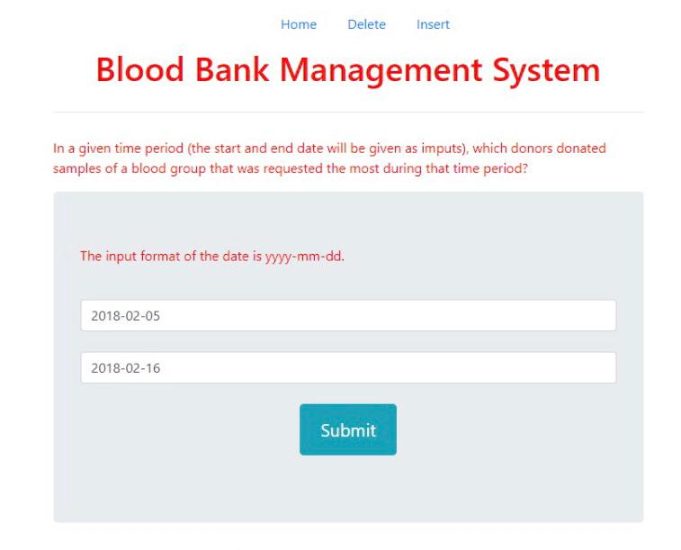

Result:

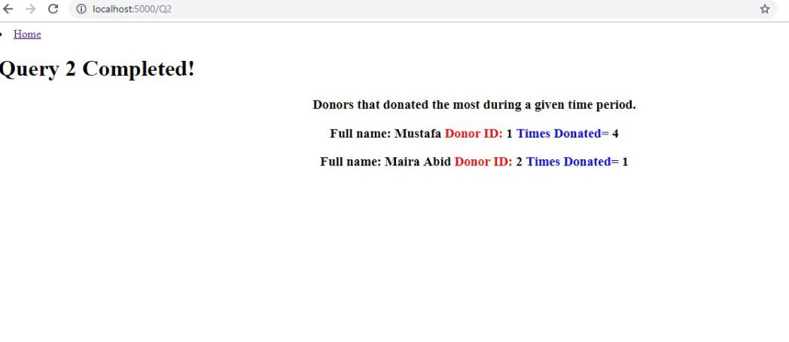

Query 3:

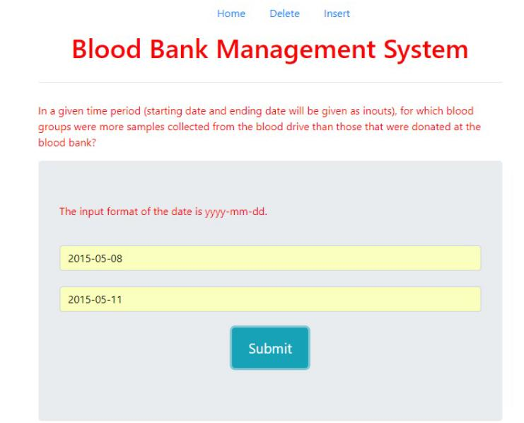

Result:

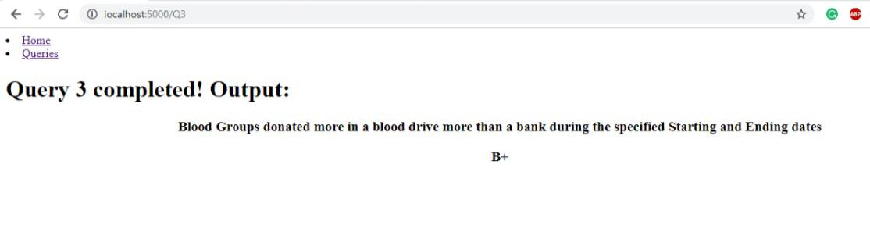

Query 4:

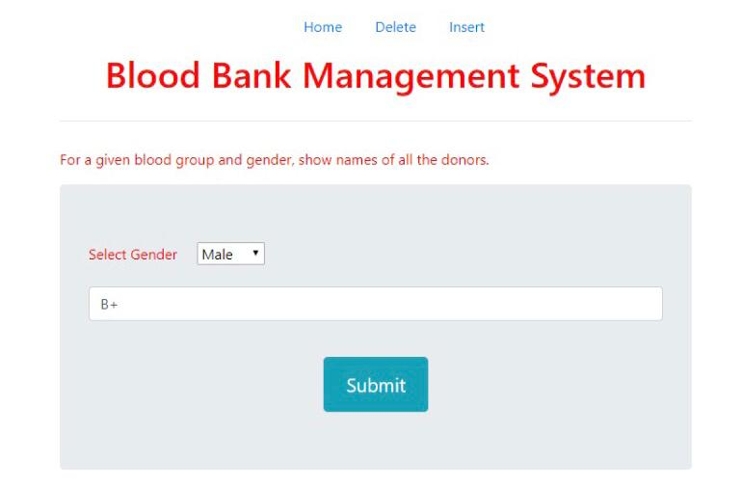

Result:

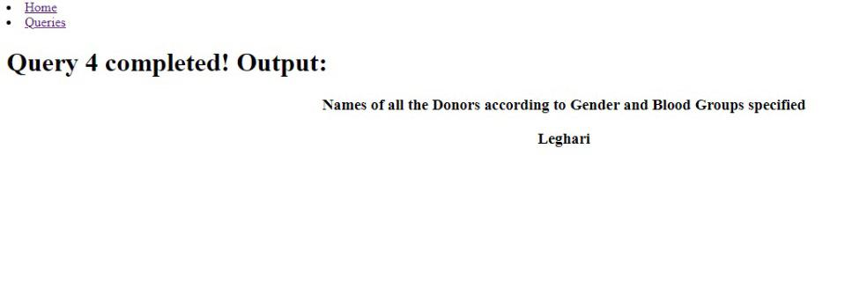

Query 5:

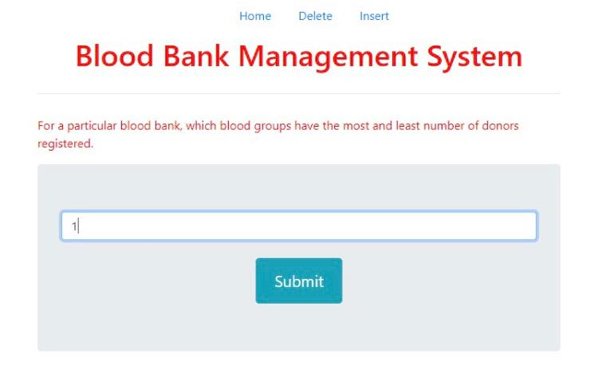

Result:

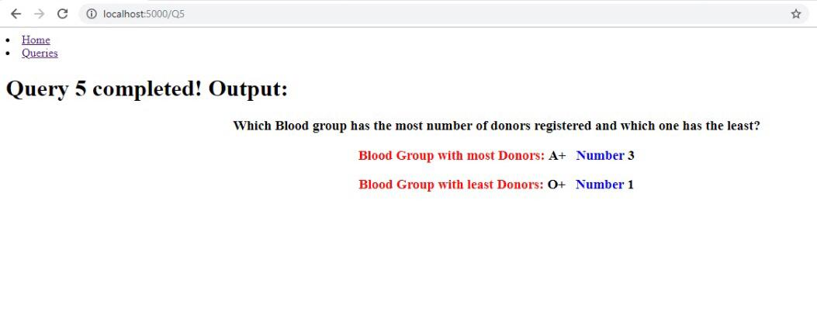

Query 6:

Result

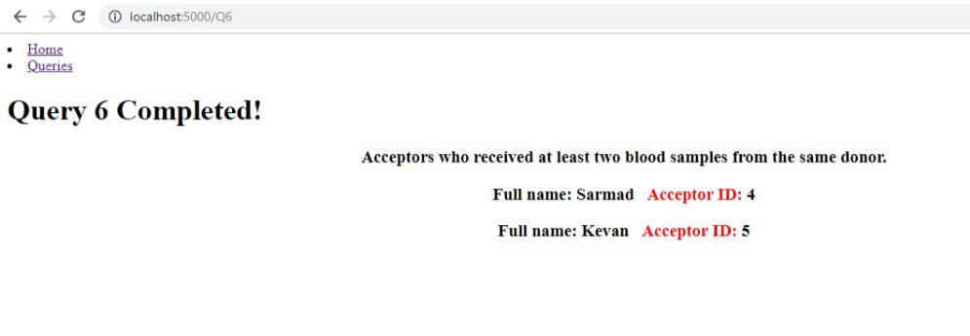

Query 7:

Result

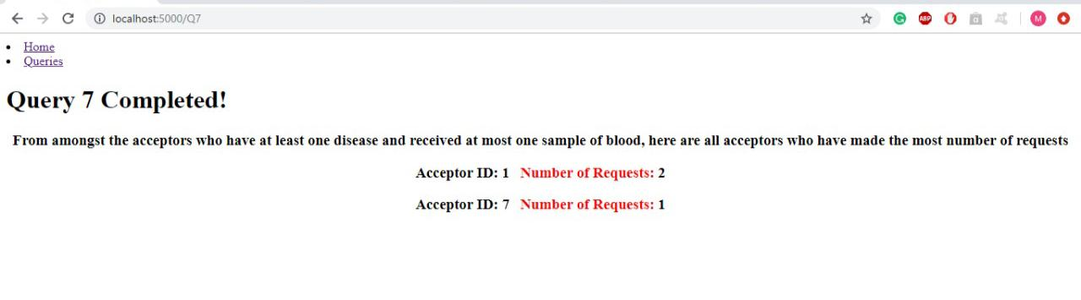

Query 8:

Result:

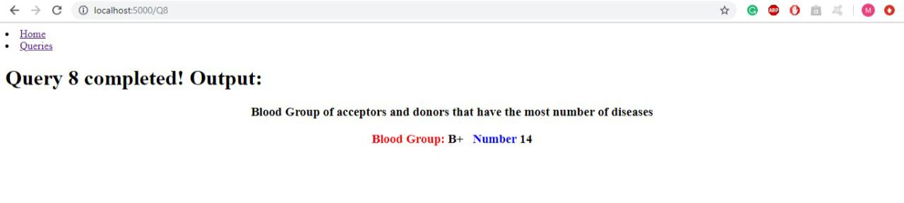

Query 9:

Result:

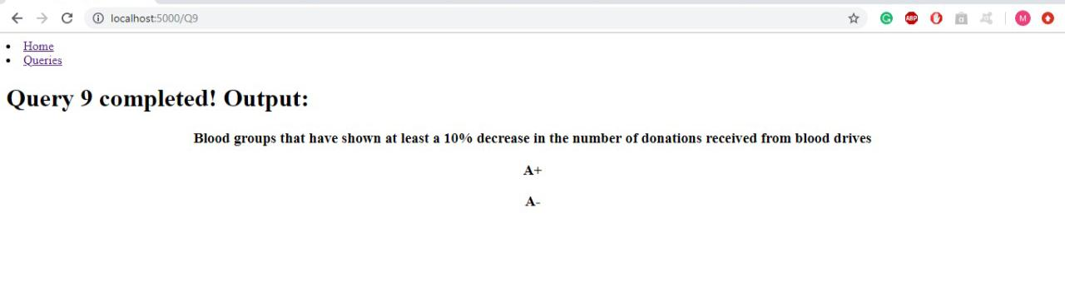

Query 10:

Result:

